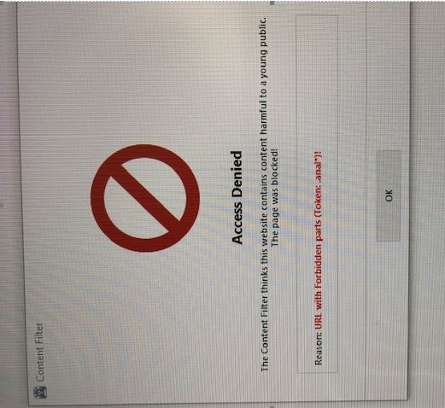

Error message displayed when using Chrome Engine
Sitekiosk version 9.8 Build 5547 (2020-08-21 00:11)

